

Outstrays to Skeffling Managed Realignment

Market Sounding Prospectus

March 2017

We are the Environment Agency. We protect and improve the environment and make it a better place for people and wildlife.

We operate at the place where environmental change has its greatest impact on people’s lives. We reduce the risks to people and properties from flooding; make sure there is enough water for people and wildlife; protect and improve air, land and water quality and apply the environmental standards within which industry can operate.

Acting to reduce climate change and helping people and wildlife adapt to its consequences are at the heart of all that we do.

We cannot do this alone. We work closely with a wide range of partners including government, business, local authorities, other agencies, civil society groups and the communities we serve.

Contents

1 Introduction 4

2 Project Details 5

3 Project Programme 6

4 Commercial Approach 6

5 Future Procurement 7

6 Disclaimer 7

7 Appendix - questionnaire 8

1. Introduction

The Environment Agency is responsible for delivering sustainable flood and coastal erosion risk management solutions and for overseeing the delivery of local solutions by others. To do this we work closely with a wide range of partners including government, businesses, local authorities, other organisations and communities - with the aim of maximising the benefit for people and the environment from each pound we spend.

Our [Sustainable Engineering Procurement Strategy](http://www.environment-agency.gov.uk/static/documents/Business/Engineering_a_Better_Environment.pdf) - Engineering a Better Environment - seeks to ensure we deliver value for money in creating a better place for people and the environment. Over the next 10 years, we will be investing more than £2.5 billion to reduce the risk of river and coastal flooding and to secure wider environmental and social benefits.

Purpose of market sounding

The purpose of this market sounding prospectus and questionnaire is to determine the interest in groups or organisations to undertake the future management of the Outstrays to Skeffling Managed Realignment site and the opportunity to influence aspects of the design, being taken through the questionnaire (see appendix 7 on page 8).

The aims of this document are;

* to give further information to interested groups/organisations about the project
* give groups/partners opportunity to help shape our approach of the management of the site.
* help the Environment Agency determine if there is sufficient potential interest in bidding for the site management contract.

Timetable

Key dates for the market sounding are as follows:

* Issue of market sounding documents - 16 March 2017
* Return of market sounding questionnaires - 13 April 2017

Response

The responses to the questionnaire will not in any way form part of any future tender assessment (for this or any other Environment Agency project), and since we are not reviewing supplier capabilities at this stage, we request that no general information of a marketing nature are submitted.

Contact details

Please return completed questionnaires to Rachael Burton by email:

[rachael.l.burton@environment-agency.gov.uk](mailto:rachael.l.burton@environment-agency.gov.uk)

Any questions should be sent to Tim Cobb who can be contacted by:

[tim.cobb@environment-agency.gov.uk](mailto:tim.cobb@environment-agency.gov.uk) or 07500 835657

2. Outstrays to Skeffling Managed Realignment - Project details

Background

The Environment Agency and Associated British Ports (ABP) are working in partnership to develop a scheme to provide new, compensatory intertidal habitat at Outstrays, Welwick and Skeffling.

The Humber Estuary is of significant environmental importance and it is protected by legislation. The area is a Special Protection Area (SPA) and a Special Area of Conservation (SAC) under the EU Habitats Directive and Birds Directive. It is also a Ramsar Site, protected under UK law by the Conservation of Habitats and Species Regulations 2010 and a Site of Special Scientific Interest SSSI, under the Wildlife and Countryside Act 1981. Compensatory habitat is required under UK law (Habitats and Species Regulations 2010) at designated sites to replace indirect habitat losses resulting from flood defences and sea level rise leading to coastal squeeze, and for direct losses from development.

The Humber Flood Risk Management Strategy (HFRMS) sets out the work needed to manage tidal flood risk along the Humber floodplain. Compensatory habitat is needed to enable the Environment Agency to continue to undertake important flood risk management work around the Humber estuary as identified in the HFRMS. ABP requires compensatory habitat for areas along the estuary that will be lost through future port expansion and development.

The habitat creation site will be designed so that natural processes are maximised, where appropriate, and space is created that allows for the natural migration of intertidal habitats. From an Environment Agency perspective, the site will provide compensation (under the Habitats Regulations) for habitat losses in the middle and outer-north parts of the Humber Estuary resulting from coastal squeeze and flood risk management. The site will also aim to compensate for habitat lost as a result of ABP port development. Specific habitat and bird number targets will also form part of the objectives and will be finalised as the scheme progresses and as losses are identified.

There are a number of shared Environment Agency and ABP objectives. The works to create habitat should benefit and not have an adverse effect on:

* Flood risk;
* Drainage;
* Biodiversity; and
* Promote socio-economic benefits, e.g. recreation, amenity and landscape.

Current stage of project development

After recent acquisitions of large areas of land needed for the scheme (through land purchase and early release of long term tenancy agreements), the remaining smaller parcels of land are currently being acquired through land swaps for nearby fields (under Environment Agency ownership). This is relatively low risk and there is high confidence the remaining land will be acquired over the next few months.

During this time, the initial design parameters for the site have begun to take shape in terms of defining the extent of the managed realignment, breach locations and where intertidal habitat will be created. An outline of opportunities and constraints within the site have been identified, although the detail of the design is yet to be taken forward.

We are currently developing the outline design (working with national and local stakeholder and organisational groups and the local community) that will inform the planning submission and covers key aspects including, but not limited to:

- Management of flood risk and land drainage issues from around the site; --

- Footpath/Bridleway access around the site;

- Amenity aspects for public enjoyment (with the footpaths above, these need to be carefully considered against minimising and mitigating for bird disturbance);

- Habitat types within the site and how these might be managed in the short, medium and long term;

3. Project Programme

The anticipated programme dates are as follows. These dates will be updated as required:

|  |  |
| --- | --- |
| Activity | Date |
| Appointment of Site Manager - pre-planning and detailed design support | June 2017 |
| Submission of planning (West) | September 2017 |
| Submission of planning (East) | November 2017 |
| Planning approval (West site) | March 2018 |
| Planning approval and other consents (East site) | October 2018 |
| Scheme funding approved (EA) | March 2018 |
| Contract Award (Design and Build Contractor) | April 2018 |
| Commence construction (West) | April-May 2018 |
| Commence construction (East) | Spring 2019 |
| Construction completion (East - breaches) | October 2020 |
| Appointment of Site Manager - Lease agreement or Contract | Summer/Autumn 2020 - TBA |

4. Commercial approach

The Environment Agency are looking to appoint a site manager to work with the Outstrays to Skeffling Managed Realignment Project Team to implement the managed realignment scheme.

It is anticipated that the first stage of the appointment would involve the site manager assisting with the development of the outline design for planning submission and then for further detailed design with the design and build contractors (to be appointed).

We are anticipating that once construction is complete the successful project partner will take on the formal role of site manager. This will either be done by a separate contract or by a long term lease agreement covering either all or parts of the site (depending on the design, and lease arrangements for EA/ABP land etc). Potentially this could be in the order of 400-450ha for the whole site.

5. Future procurement

Shortly after receiving the questionnaires, we will send out a tender pack to interested groups and organisations to tender for the site management role. This tender pack will include a requirement for groups/organisations to provide details of their accounts and liability insurances. The tender will be issued via Bravo, which is our electronic tendering website. All interested groups and organisations will receive further information on this and how to register prior to the tender being issued.

Further procurement will be undertaken later in 2017 for the detailed design and construction of the site (from the EA and ABP supplier frameworks), which will be appointed following necessary external approvals (planning, MMO, footpath diversions etc) and internal Environment Agency and ABP approvals to authorise funding for the scheme.

6. Disclaimer

This document does not formally signify the beginning of a procurement process and does not constitute a commitment by the Environment Agency to undertake any procurement exercise. In the event that we decide to formally commence the procurement of services of a site management partner for the Outstrays to Skeffling Managed Realignment site, an invitation to tender will be issued via Bravo.

7 Appendix - Questionnaire

You are invited to respond to the following questions. A lengthy response is not expected and you are encouraged to limit your response to a maximum of 1000 words in total. Your response will be considered without prejudice basis.

1. Are you able to obtain and utilise both external funding and your organisation’s own financial resources to invest in the future management of the site?

2. How do you intend to utilise resources from within the local communities and volunteering to help manage the site and ensure community buy-in?

3. Community involvement and buy-in is key to the success of managed realignment; how would you work with local communities, the Environment Agency and ABP to construct and maintain this site in a way that promoted the best relationships between all?

4. Would you be interested in bidding to undertake monitoring of the site (e.g. birds and other wildlife surveys), either as part of this tender or under a separate tender? Can you demonstrate any efficiencies undertaking the site monitoring and part of the site management role?

5. What do you see as the key constraints and risks in delivery of the project to achieve our timescales?

6. At this early stage would you be interested in tendering for this project? What factors may influence this decision?

7. Would a site visit, and/or presentation be of benefit? Or would the preference be to defer until the tender pack has been issued?

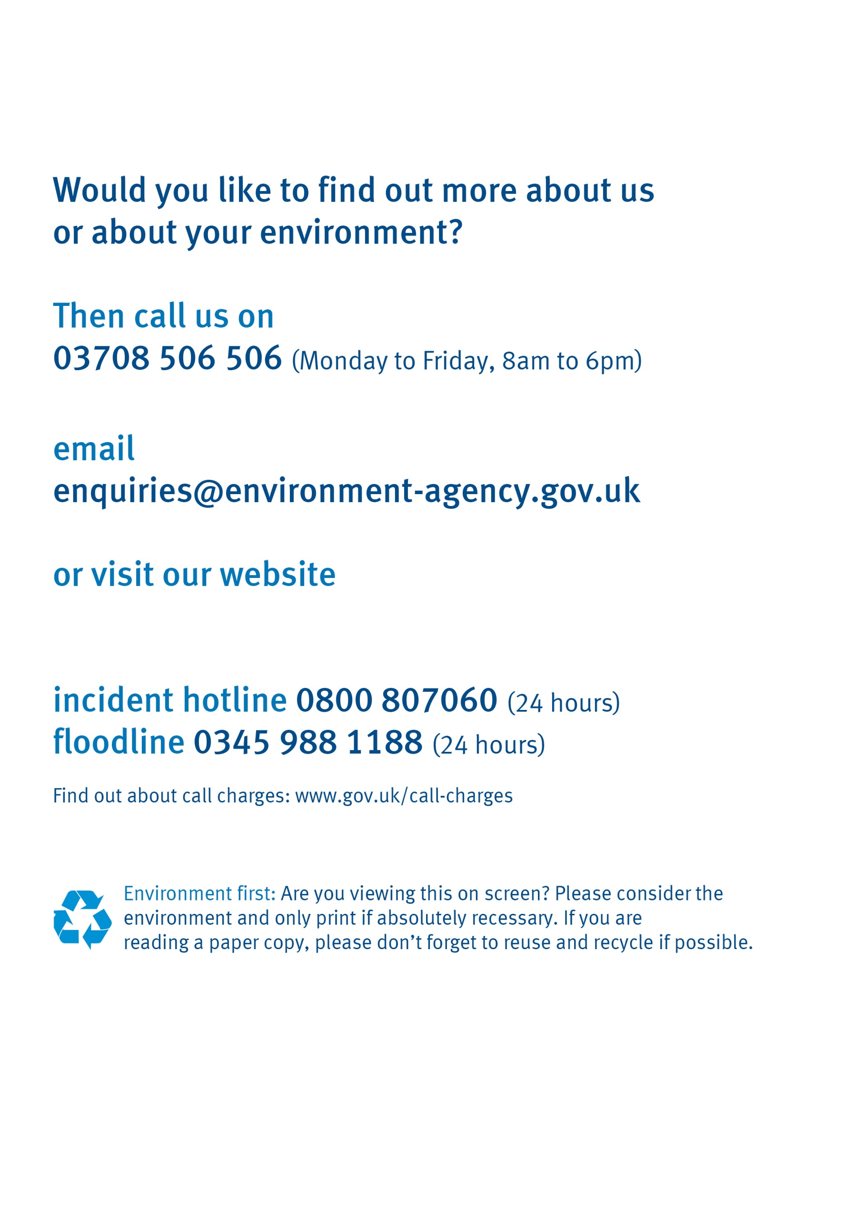

www.gov.uk/environment-agency